Basic Bringup of PLL-Evalboard-Synthesizer

Rich Rademacher, University of Waterloo/IQC

January 2018

# Introduction

This document describes the bring up of our Phase-Locked Loop (PLL) frequency synthesizer for generating medium-precision RF carrier wave (CW) signals. The Quantum Ion Trap group at the Institute for Quantum Computing (IQC) uses a series of evaluation boards from Analog Devices and Perigrine Semiconductor to provide a low-cost series of RF drive signals.

# Initial Bring Up of ADF41020 Evaluation Board

The evaluation board is shown below:

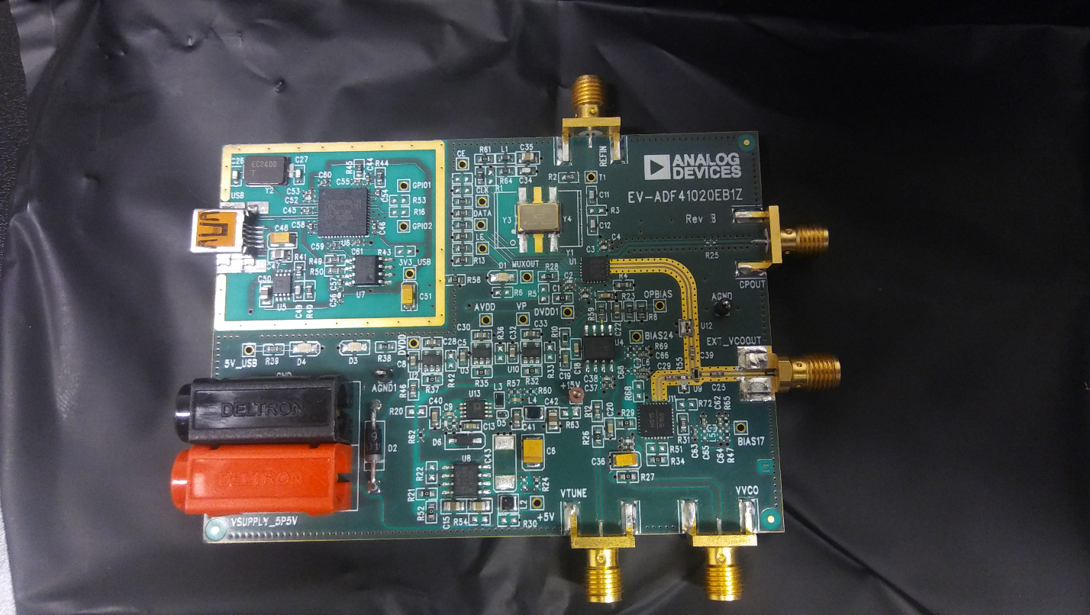

Figure Microwave Synthesizer Showing Location of VCO

## Programming Software

The on-chip programming software from the ADI website is at <http://www.analog.com/media/en/evaluation-boards-kits/evaluation-software/ADI_Int-N.zip>. This software is required to operate the board without using the Raspberry Pi.

## Powering the EVB

An external power supply of +5.5V is required. USB power for communication is also required if not using the Raspberry Pi

# Initial Bring Up of ADF4355-2 Evaluation Board

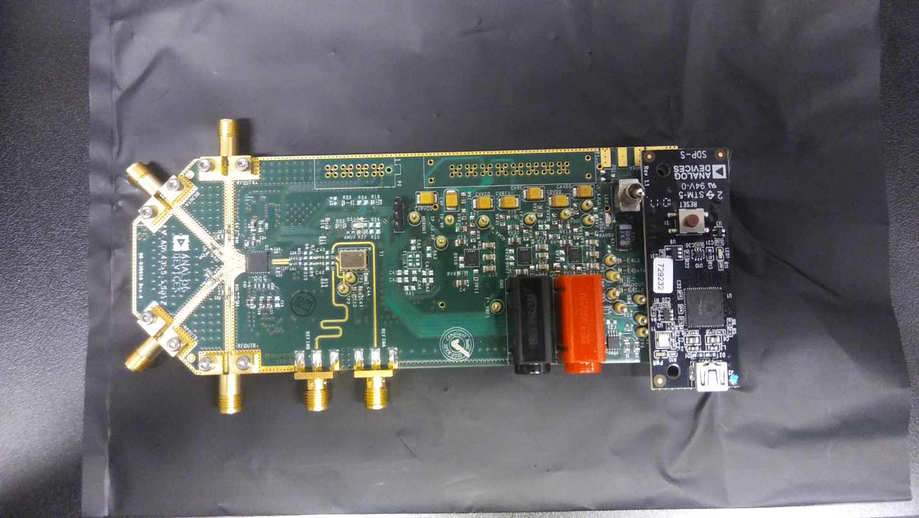

Figure RF Synthesizer Board with USB Programmer Attached

## Programming Software

Programming software located at <http://www.analog.com/media/en/evaluation-boards-kits/evaluation-software/ADF4355_v1_2_3.zip>. This evaluation board must be connected to the SDP-S USB controller for standalone operation. The SDP-S is not required when using the Raspberry Pi.

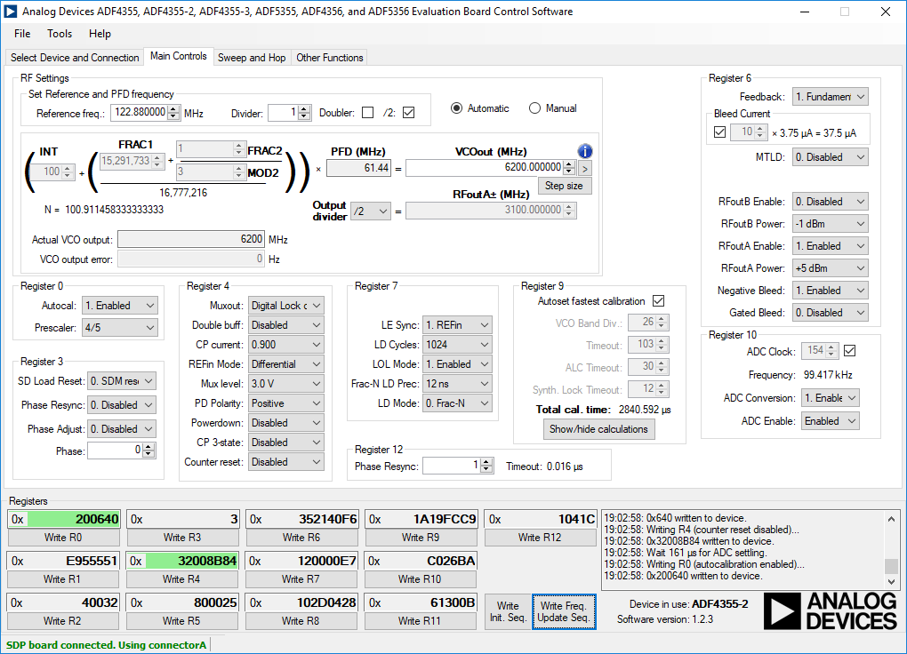

Figure RF Synthesizer PC Programming Screen showing Frequency Reginsters and Programming Buttons

* The Initialization button must be pressed prior to programming the frequency
* The frequency button must be pressed after the initialization button to update frequency.
* Programming the frequency must take into account the limited range of the VCO on-board the PLL chip. Its range is 3.3 GHz to 6.8 GHz. Use the output divider to set the proper RFoutA frequency.

# Bring up of the Programmable Attenuator Board

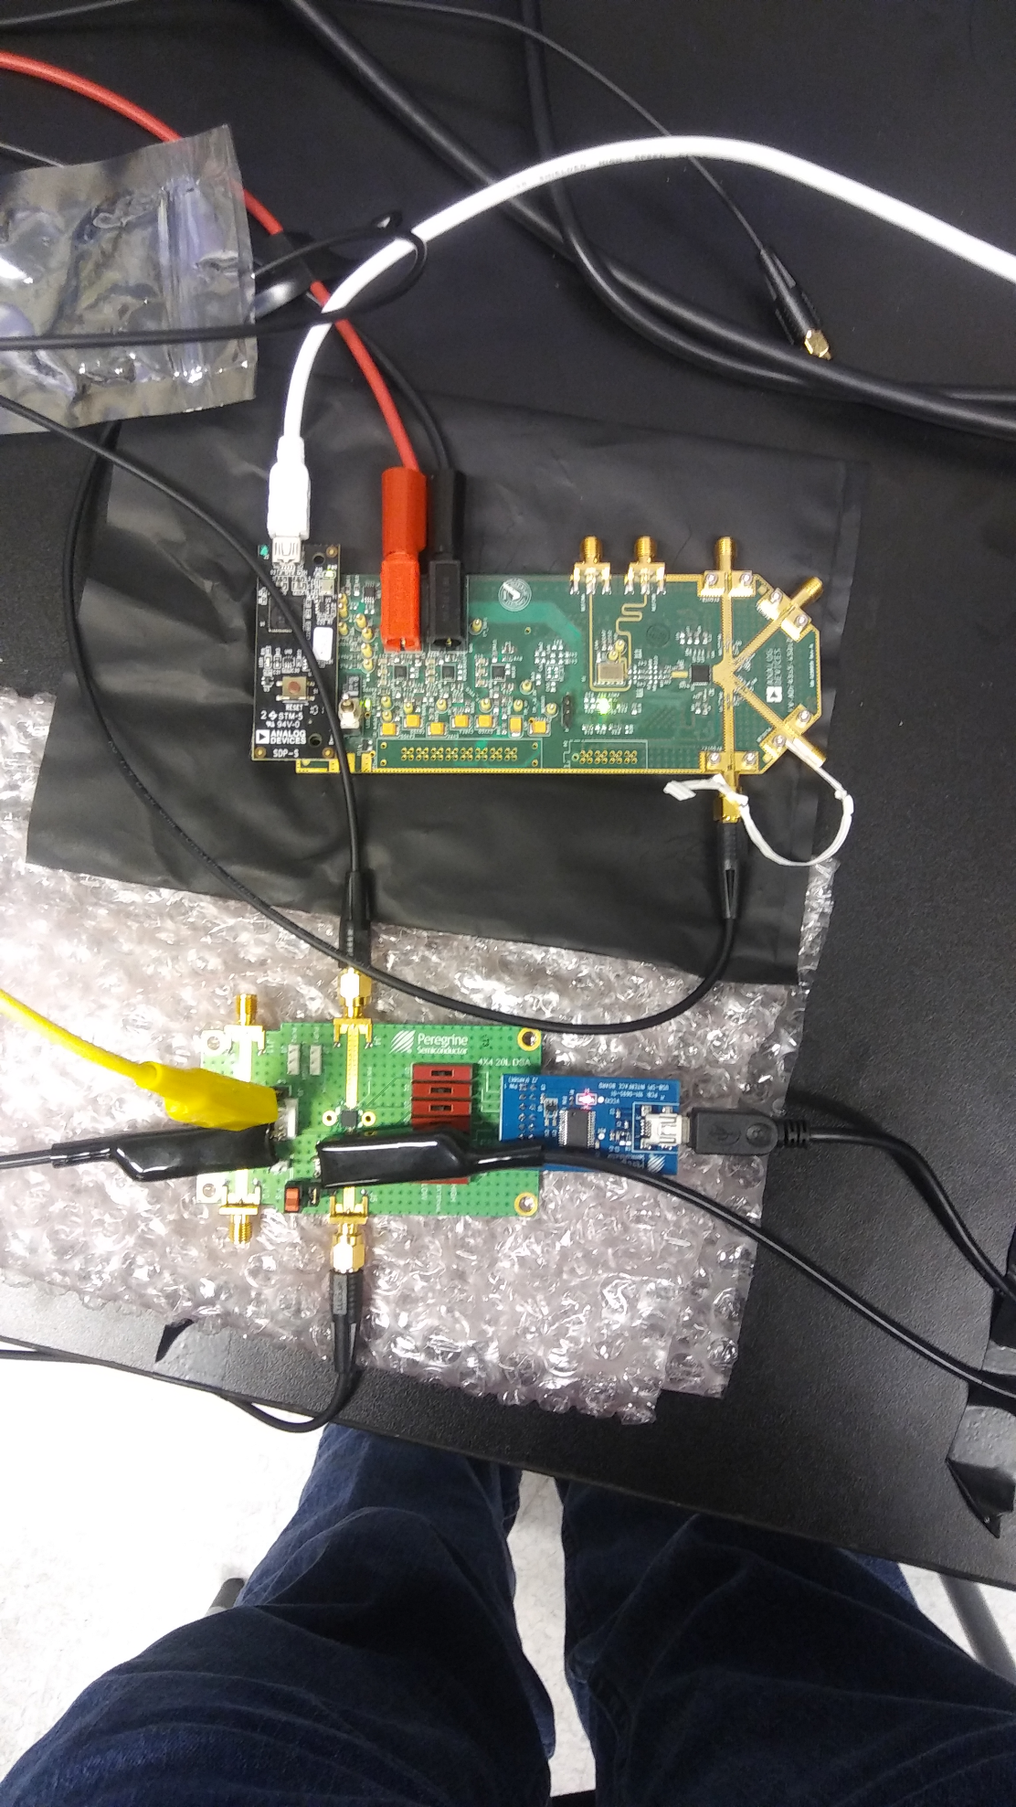

Figure RF Synthesizer with Attenuator Board

The programming software for the Peregrine Semiconductor EK4312 evaluation board is at <http://www.psemi.com/products/digital-step-attenuators-dsa/pe4312>.

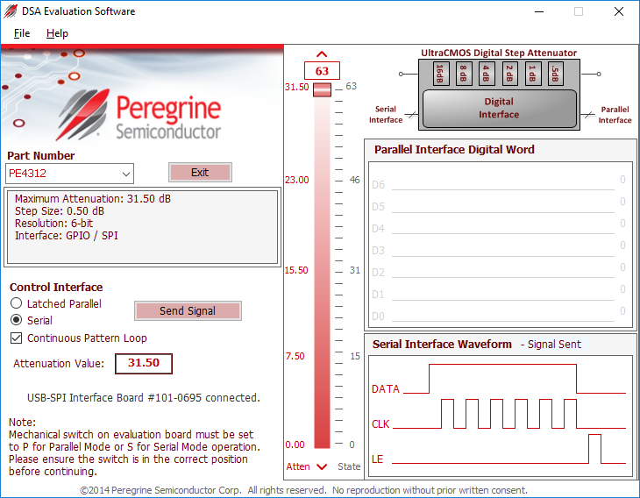

* Power supply for the Peregrine board requires 3.3V. The VDD and VDD_DIG connections on J9 should be connected using jumper JP3. The evaluation board manual makes mention of a negative supply of -3.3V on VSS but this can be set to GND for lab use.
* The VSS and GND connections should be shorted together using jumper JP1.
* The P/S switch J10 should be set to S for serial operation using the USB controller and SPI.

# Bring up of Raspberry Pi

The Raspberry Pi is shown below: